EVERYONE NEEDS FRIENDS –
SO WOULD YOU LIKE TO BE OUR FRIEND?
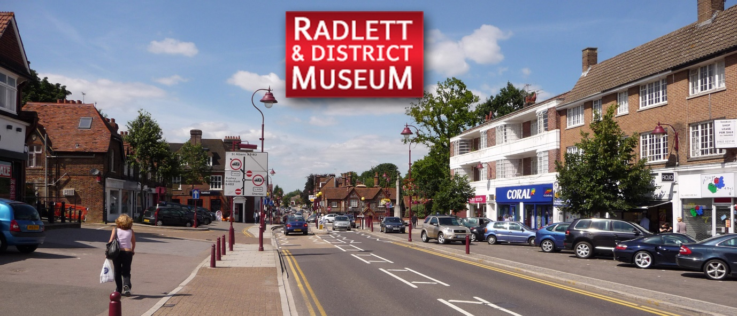
For as little as £10 (£15 per couple) per year you can support the Museum, which is run entirely by volunteers.
As a Friend, you will receive advance notice of the events and exhibitions. You will also be invited to special events and be eligible for discounted rates on certain events.
You will be sent newsletters and communications by email, if you agree to this, thus saving the Museum postage costs.
We hope that you decide to become a Friend and, if you do, please download the application form, by clicking the link below, and return it to:
Liz Mitchell,
Friends of Radlett & District Museum,
c/o 66 Williams Way,
Radlett,
WD7 7HB

or send by email to-
friends@radlettmuseum.com
If you have any questions, please feel free to contact Liz.

Application to join Friends of Radlett and District Museum
I / we* would like to join the ‘Friends of Radlett & District Museum’.
NAME:………………………………………………………………………………………..
ADDRESS:…………………………………………………………………………………..
POST CODE:……………………………..
TELEPHONE NUMBER(S):………………………………………………………………
EMAIL:…………………………………………………………………………………………
We will send the newsletter by email and assume that you agree to this. This will save the Museum postage.
I/we consent to my/our contact details being held on the Museum’s database in order to contact you about:
- Administration of subscriptions
- Circulation of Newsletter and other Museum-related mailings
- Information of any meetings events or outings
Payment can be made the following ways [please indicate]:
□ I / we* will agree to pay subscriptions of £10 / £15* by an annual bankers standing order to:
Radlett & District Museum
CAF Bank
Sort code 40-52-40
Account number 00037215
□ I / we* wish to pay by cheque, attached made payable to:
Radlett & District Museum
SIGNED:…………………………………………………………….DATE:…………………………….

Please send completed form and payment: to
c/o Liz Mitchell,
66 Williams Way,
Radlett, Herts.
WD7 7HB

